

<(NAME) Project: (Workstream NAME)>

<Title: Design Specification Template>

<Version>.<Revision>.<Errata>

**Design Specification Template**

Effective XXXX, 2024

Author: <Primary>

Author: <Secondary. Delete if unnecessary>

# Version History

| DELETE THIS BLOCK |
| --- |
| ***INSTRUCTIONS FOR ALL FOLLOWING SECTIONS:***   * + *This section is only required if there is a directly linked preceding document which means this is a revision to the original document. If this is a completely new version (original) you may delete this page.*   + *The revisions in the populated table below apply to the template, please start from a blank table for your contribution.*   + *See the OCP Release Nomenclature Guidelines for additional information.* |

Note, refer to the OCP Contribution Versions, Revisions and Errata best practices documentation. Generally speaking, Versions and revisions are made to this document and logged here. Errata is a separate document such that the contribution specification document it refers to was not revised. Ex: Version 1, Errata E1

| **Date** | **Version #** | **Author** | **Description** |
| --- | --- | --- | --- |
| 03 JUL 23 | 1.1 | Bijan Nowroozi | Edited the goals in the overview for clarity |
| 08 AUG 23 | 1.2 | Bijan Nowroozi | Changed some of the sustainability text |
| 06 NOV 23 | 1.3 | Bijan Nowroozi | Terminology changes and edits for clarity |
| 30 SEP 24 | 1.4 | Bijan Nowroozi | Added usage note and compliance sections, updated numbering |
| 07 NOV 24 | 1.5 | Bijan Nowroozi | Reflected New License, cleaned up instructional text boxes, tenets, change log |
| 10 DEC 24 | 1.6 | Bijan Nowroozi | Arm System Ready changes per Arm Review |
|  |  |  |  |

# Current Template Version:

OCP Modular Design Specification Template V1.6.0

**Table of Contents**

**Version History 2**

**Current Template Version: 3**

**1. License 5**

**1.1. Open Web Foundation (OWF) CLA 5**

**1.2. Acknowledgements 6**

**2. Compliance with OCP Tenets 7**

**1.1. Openness 7**

**1.2. Efficiency 8**

**1.3. Impact 8**

**1.4. Scale 8**

**1.5. Sustainability 8**

1.1. Description 10

1.2. User Requirements/User Stories 10

1.3. Solution Architecture 10

1.4. Supported Functions 10

1.4.1. Environmental Regulatory Compliance and Design 10

1.5. Non-Functional Requirements 11

1.6. Features 11

1.7. Physical Design 12

1.8. Mechanical Design 12

1.8.1. Rack Compatibility 13

1.8.2. General Requirements 13

1.9. Electrical Requirements 13

1.10. Thermal Design Requirements 14

1.11. Onboard Power 14

1.12. Interfaces 15

1.12.1. Signal List 15

1.12.2. Rear Side Power, I/O, Expansion Board and Midplane Subsystems 16

1.13. Performance 16

1.14. Security 17

**1.15. Hardware Management 17**

1.16. Constraints 18

1.17. Test and Validation 19

**Provide the concepts for testing and validation of this solution. 19**

1.18. External Software/Firmware Support (Strongly recommended) 19

1.19. Compliance 19

1.20. Arm SystemReady (only for Arm-based Systems) Requirement 20

1.21. Repository Location 21

1.22. Prescribed Materials 21

1.23. References (recommended) 21

**Appendix A - Checklist for IC approval of this Specification (to be completed by contributor(s) of this Spec) 22**

**Appendix B - Contribution Process FAQs 23**

# License

THE UPDATED DEFAULT CONTRIBUTOR LICENSE AGREEMENT (CLA) IS [**OWFa 0.9**](https://146a55aca6f00848c565-a7635525d40ac1c70300198708936b4e.ssl.cf1.rackcdn.com/images/ed0befaf86bee2568ad720ff4a9a554d1f4260f7.pdf). PLEASE VERIFY THE CORRECT CLA/FSA IS USED AND EXECUTED FOR THIS CONTRIBUTION.

## Open Web Foundation (OWF) CLA

Contributions to this Specification are made under the terms and conditions set forth in **Modified Open Web Foundation Agreement 0.9 (OWFa 0.9)**. (As of October 16, 2024) (“Contribution License”) by:

**[Contributor Name(s) or Company name(s)]**

Usage of this Specification is governed by the terms and conditions set forth in **Modified OWFa 0.9 Final Specification Agreement (FSA)** (As of October 16, 2024) **(“Specification License”).**

You can review the applicable Specification License(s) referenced above by the contributors to this Specification on the OCP website at <https://www.opencompute.org/contributions/templates-agreements>.

​​For actual executed copies of either agreement, please contact OCP directly.

**Notes**:

The above license does not apply to the Appendix or Appendices. The information in the Appendix or Appendices is for reference only and non-normative in nature.

NOTWITHSTANDING THE FOREGOING LICENSES, THIS SPECIFICATION IS PROVIDED BY OCP "AS IS" AND OCP EXPRESSLY DISCLAIMS ANY WARRANTIES (EXPRESS, IMPLIED, OR OTHERWISE), INCLUDING IMPLIED WARRANTIES OF MERCHANTABILITY, NON-INFRINGEMENT, FITNESS FOR A PARTICULAR PURPOSE, OR TITLE, RELATED TO THE SPECIFICATION. NOTICE IS HEREBY GIVEN, THAT OTHER RIGHTS NOT GRANTED AS SET FORTH ABOVE, INCLUDING WITHOUT LIMITATION, RIGHTS OF THIRD PARTIES WHO DID NOT EXECUTE THE ABOVE LICENSES, MAY BE IMPLICATED BY THE IMPLEMENTATION OF OR COMPLIANCE WITH THIS SPECIFICATION. OCP IS NOT RESPONSIBLE FOR IDENTIFYING RIGHTS FOR WHICH A LICENSE MAY BE REQUIRED IN ORDER TO IMPLEMENT THIS SPECIFICATION. THE ENTIRE RISK AS TO IMPLEMENTING OR OTHERWISE USING THE SPECIFICATION IS ASSUMED BY YOU. IN NO EVENT WILL OCP BE LIABLE TO YOU FOR ANY MONETARY DAMAGES WITH RESPECT TO ANY CLAIMS RELATED TO, OR ARISING OUT OF YOUR USE OF THIS SPECIFICATION, INCLUDING BUT NOT LIMITED TO ANY LIABILITY FOR LOST PROFITS OR ANY CONSEQUENTIAL, INCIDENTAL, INDIRECT, SPECIAL OR PUNITIVE DAMAGES OF ANY CHARACTER FROM ANY CAUSES OF ACTION OF ANY KIND WITH RESPECT TO THIS SPECIFICATION, WHETHER BASED ON BREACH OF CONTRACT, TORT (INCLUDING NEGLIGENCE), OR OTHERWISE, AND EVEN IF OCP HAS BEEN ADVISED OF THE POSSIBILITY OF SUCH DAMAGE.

## Acknowledgements

The Contributors of this Specification would like to acknowledge the following companies for their feedback:

List all companies or individuals who may have assisted you with the specification by providing feedback and suggestions but did not provide any IP.

| DELETE THIS BLOCK BEFORE SUBMITTING |
| --- |
| INSTRUCTIONS FOR THE FOLLOWING SECTIONS:   * The Tenets section is required for contribution. * Replace the section text (keep titles) * Please describe how this Specification complies to the following OCP tenets. * Compliance is required for at least four of the five tenets (Sustainability is a required tenet). * The ideals behind open sourcing stipulate that everyone benefits when we share and work together. Any open source project is designed to promote sharing of design elements with peers and to help them understand and adopt those contributions. There is no purpose in sharing if all parties aren't aligned with that philosophy. * The OCP Steering Committee will look beyond the contribution for evidence that the contributor is aligned with this philosophy. The contributor actions, past and present, are evidence of alignment and conviction to all the tenets. * Scope section contains information for the contributor, all of it is expected to be replaced. |

# 

# Compliance with OCP Tenets

Please describe how this Specification complies with the OCP tenets.

A full explanation of the OCP core tenets can be seen [here](https://146a55aca6f00848c565-a7635525d40ac1c70300198708936b4e.ssl.cf1.rackcdn.com/images/bf648bb75091907147e76846cad590f402660d2e.pdf).

## Openness

Openness is measured by the ability of third parties to build, modify, or personalize your contributed device, platform, or software. The OCP aims for completely open platforms that include all programmable devices, firmware, software, mechanical and electrical design elements, and any necessary external components or tools like software utilities. Contributors are highly encouraged to collaborate with other OCP Projects that may have complementary knowledge and expertise. Actively remove barriers to openness and demonstrate collaboration by sharing, seeking feedback, and accepting changes to designs and specifications. Ensure your contribution can be extended and enhanced by others.

## Efficiency

Your contribution should be more efficient than existing or prior generations. Efficiency can be demonstrated through reduced operational and capital expenses, improved performance, modularity, increased capacity, lower power or water consumption, better utilization, reduced size, or minimized code weight and latency in software. Clearly express efficiency gains with metrics valued by end-users when proposing your contribution.

## Impact

Your contribution should have a transformative impact on the industry by introducing new technology, accelerating time-to-market, or enabling technology through global supply chains. Impact is amplified when new technologies are made accessible to many customers worldwide. Examples include widely adopted specifications or more specifically, open security features that establish and verify product trust. Ensure your contribution creates meaningful positive impact within the OCP ecosystem.

## Scale

Design your contribution for easy implementation and deployment at any scale, with minimal intervention. Aim to create additive solutions where minimal usage or instances can be deployed and incrementally scaled as needed to effectively address the entire problem. Provide all necessary tools and supporting documentation, such as installation guides, initialization processes, configuration information, and details on obtaining service support. Include features like simple manual and automated maintenance, remote management, upgradability, and error reporting. Management tools should be open-sourced and/or made available to adopters.

## Sustainability

Your contribution must be sustainable, maximizing transparency of environmental impacts with the goal of continuous improvement. Focus on the responsible use of natural resources, fostering positive societal impacts, and minimizing environmental harm. This can be achieved through design decisions that promote circularity, efficient use of materials, power-saving features, and sustainability labeling. For software, consider optimizing code to reduce resource consumption and incorporating features that enable energy efficiency.

Reminder to authors, this section refines the previous section, so it’s unnecessary to strictly repeat the previous sections, only add what modifies and refines the previous. This section is for the Design Specifications. If a Base Specification provides general requirements and design goals, the Design Specifications has detail that further defines what specific role this contribution plays, and enough detailed design information such as high level board layouts, enumerations, etc that enables end users to utilize this part of the specifications to begin the journey to realize this design.

## Description

*Provide a high-level overview of the solution, including its key features, intended users, and any assumptions made during development.*

## User Requirements/User Stories

*Include all end-user requirements and user stories that describe what the solution is supposed to do. Note that users may include other subsystems or platforms.*

## Solution Architecture

Provide a detailed view of the solution’s elements, interfaces, and other significant components. Support this section with a diagram that visually represents the structure and relationships between various parts, illustrating how they interact and function together.

## Supported Functions

*List the key functions the solution must perform, detailing how users interact with it and how the system responds. Include considerations for manageability, resilience, and availability.*

### Environmental Regulatory Compliance and Design

*Please describe any environmental regulations or requirements for any platform boards and full system, if applicable..*

*Note to author of this specification: This section can include the following but is not limited to the below items:*

* *UL/CE/NRTL/FCC/IEC/EN/etc Requirements*
* *RoHS/WEE directives, REACH regulations*
* *NEBS compliance requirements*
* *Operating temperature range*
* *Storage temperature range*
* *Transportation temperature range*
* *Shock and Vibration requirements*
* *Operating Altitude*

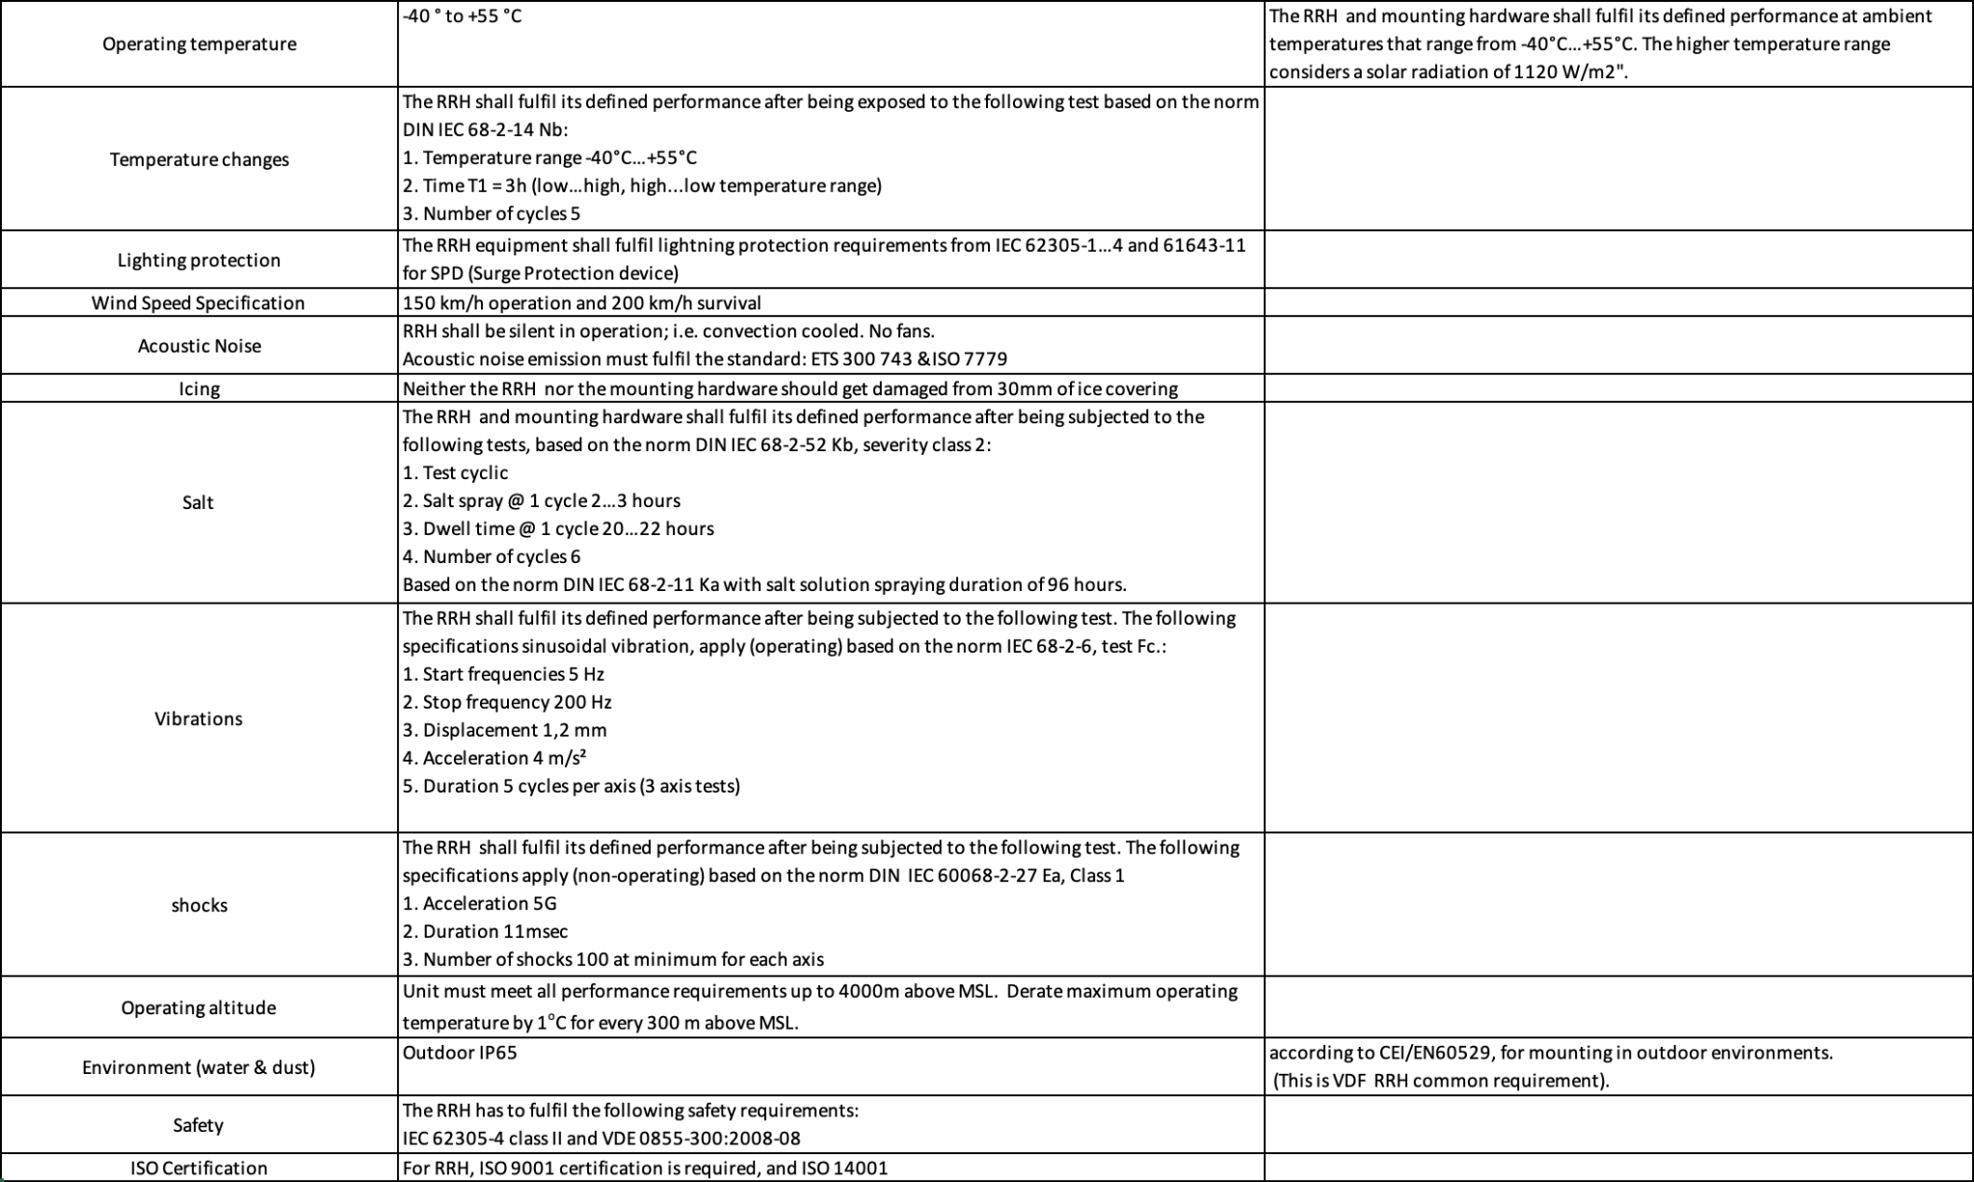

Example Outdoor Equipment Environmental Requirements

## Non-Functional Requirements

*Describe qualities such as performance, usability, security, and maintainability that the software must exhibit.*

## Features

*Break down the solution’s specific features, explaining the purpose and functionality of each one.*

## Physical Design

*Please describe the physical requirements for your contribution. This may be the limitations of the physical envelope.*

*If this specification defines a chassis type system, be sure to include the description of the chassis and associated modules, midplane, backplanes etc….*

*Note to author of this specification: This section can include the following but is not limited to the below items:*

* *Block Diagrams*
* *Form Factor Requirements*
* *Figures & Illustrations*

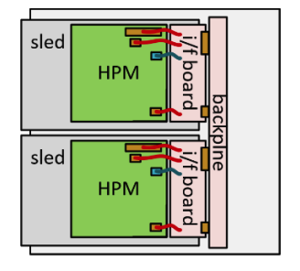

Sample Physical Diagram

## Mechanical Design

*Please describe any key mechanical requirements of your contribution.*

## Rack Compatibility

*Please describe if your contribution will be used in a rack installation. If the contribution is rack mountable, the specification must be compliant with one of the following OCP approved rack types: OpenRack (V3.X and beyond), EIA-310, OpenEdge.*

## General Requirements

*Note to author of this specification: This section can include the following but is not limited to the below items:*

* *Chassis*
* *Single sled/double sled*

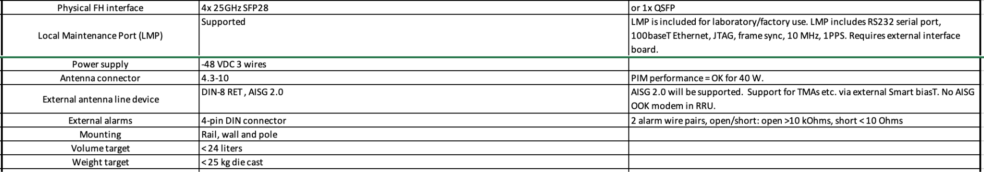

Dual-Band RRU Mechanical Requirements

## Electrical Requirements

*Please describe general electrical power requirements. Example: Power Input envelope +48VDC, 110VAC, peak/average power, etc…*

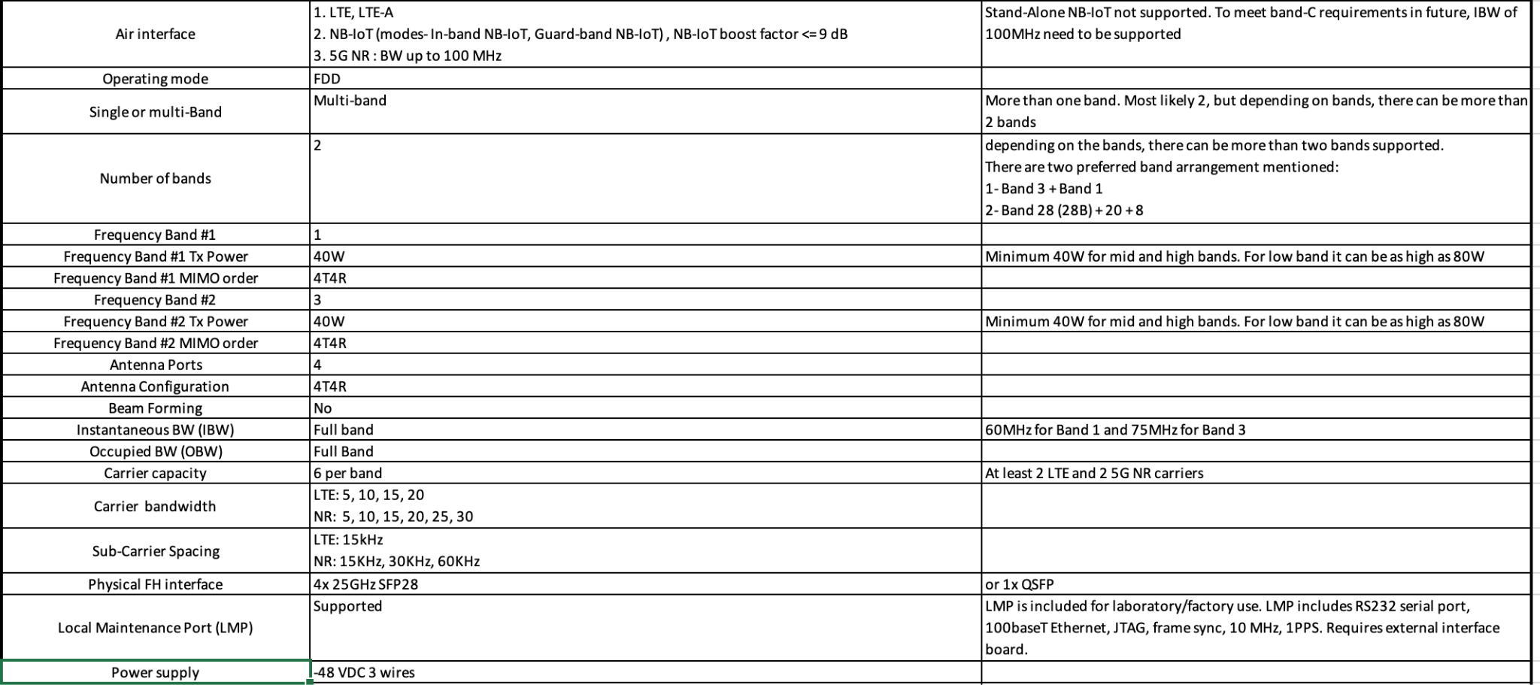

Dual-Band RRU Electrical Requirements

## Thermal Design Requirements

*Please describe the thermal design requirements for your contribution and any CFD and/or thermal models etc...*

*Note to author of this specification: Examples include:*

* *Cooling Media*
* *Flow Management*
* *Fan Controls*

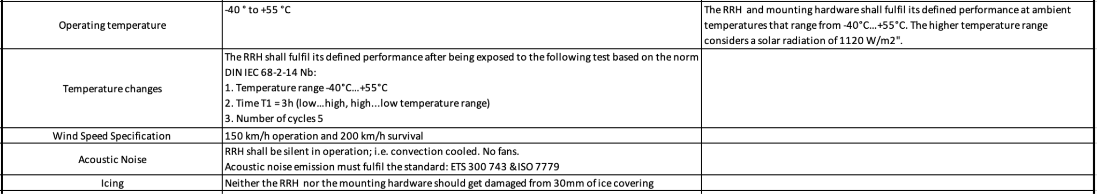

Example: Dual-Band RRU Thermal Requirements

## Onboard Power

*Please describe the architecture of the power systems and requirements in your contribution.*

*Note to author of this specification: This section can include the following but is not limited to the below items:*

* *Voltage Regulation*
* *Power Management*
* *Input voltages*
* *Hot swap controller circuit*
* *Hard drive power*
* *Power Tree*
* *Power Policy*
* *Power Budget*
* *Platform Budget*
* *Capacitive Load*

**

Example: Dual-Band RRU Power Supply Requirements

## Interfaces

*Explain how the solution will interact with other systems or users, including hardware interfaces, software APIs, or communication protocols.*

*Please describe the I/O System of the contribution, be sure to delineate the control and data planes. Block diagrams here.*

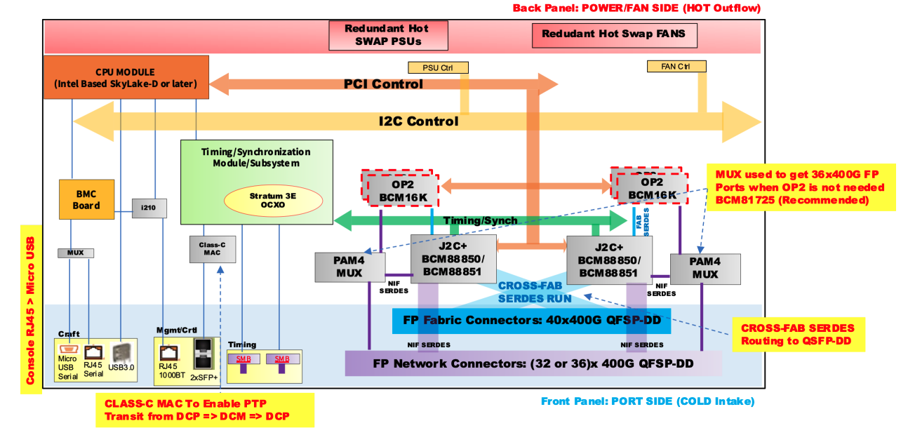

Sample Block Diagram Showing Interfaces

## Signal List

*Note to author of this specification: Examples only*

* *Power and Ground*
* *Synchronization/Clocks*
* *PCIe*
* *i2C/i3C*
* *GPIO*
* *USB 3.0*

## Rear Side Power, I/O, Expansion Board and Midplane Subsystems

*Please describe any modular design implementation requirements of the contribution.*

*Note to author of this specification: This section can include the following but is not limited to the below items:*

* *​​Overview of Footprint and Population Options*
* *Rear Side Connectivity*
* *Midplane*
* *Expansion*
* *Fixed, redundant, modular, pluggable, adapter?*
* *Power, Grounding etc…*

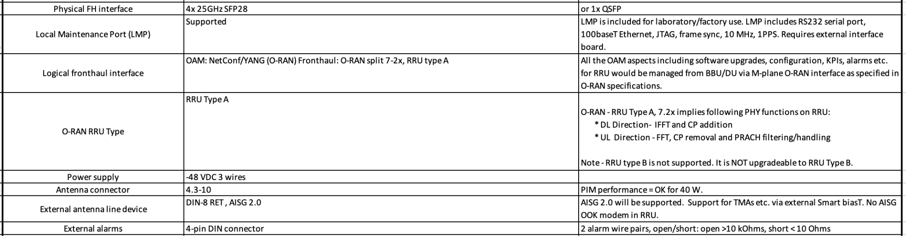

Example: Dual-Band RRU External Interface Requirements

## Performance

*Set expectations for the system’s speed and efficiency, including resource consumption targets and scalability considerations.*

## Security

*Detail the measures needed to keep the solution and end users secure from errors, cyber-attacks, or data breaches. Briefly describe the security functionalities that your specification requires and recommends. Include a “required by” date for any recommendations.*

*Note to author of this specification: This section* ***can*** *include the following but is not limited to the below items:*

* *For cryptography, key derivation, key agreement, and hashing, identify*

*o Required algorithms, modes, strengths, and usage*

*o Required compliance with national or international standards*

*o Acceptable sources of entropy*

*o Acceptable certifications of algorithm implementations*

*o Recommended certifications of cryptographic modules*

*o Recommended safeguards against cryptanalysis by quantum computers*

* *Required flow of Secure Boot starting from hardware root(s) of trust*
* *Required measurements from hardware reset through firmware*
* *Required attestation protocols*
* *Acceptable environments and processes for provisioning keys and device secrets*
* *Acceptable processes for identifying CVEs and distributing field updates to address them*
* *Acceptable Secure Boot and Attestation key lifecycle management (from generation through*
* *revocation)*
* *Recommended standards for software bills of materials*
* *Recommended firmware recovery mechanisms*

*\*Required = Required now*

*Acceptable = Required now and chosen from a list of acceptable alternatives*

*Note: Omit any items that do not apply and add any that are missing. Remember, the more detailed this specification is, the less flexibility is allowed during the design and product specification phases.*

# Hardware Management

*Please document the hardware management implementation of your contribution. Include Firmware (BIOS) optional Board Management Controller (BMC), Data Center Secure Control Modules (DC-SCM), etc.*

*Note to author of this specification: This section* ***should*** *include the following below items:*

* *Statement on whether the contribution supports out-of-band manageability.*
* *Statement on the modularity of the manageability architecture. (i.e. is an OCP management module used?)*

*Note to author of this specification: This section* ***can*** *include the following but is not limited to the below items:*

* *Architecture of out-of-band management*
  + *Dedicated or shared NIC*
  + *In which power state is the OOB management enabled*
* *A list of on-platform manageability interfaces:*
  + *Connections: I2C/I3C, SMBus, RMII,*
  + *Transport Protocol: MCTP, IPMI (KCS, BT, etc)*
  + *Commands constructs: PLDM …, IPMI, SPDM, CPER*
  + *A list of components whose firmware which can updated programmatically*
    - *Which support failover/rollback mechanisms*
  + *A list of diagnostic or management LEDs supported*
  + *A list of minimum telemetry/sensors*
  + *A list of minimum controls*
  + *Whether conformance to OCP Profiles has been tested*
  + *For Arm-based Servers, whether conformance to Arm Server Base Manageability Requirements Specification has been followed. If so, please also indicate the conformance level (e.g., M2)*

## Constraints

*List any limitations the solution must account for, such as hardware constraints, legal regulations, or specific tools that the OCP community must consider.*

*Document any hardware management implementations either dependent on or to your contribution, including firmware (BIOS), optional Board Management Controller (BMC), Data Center Secure Control Modules (DC-SCM), etc.*

## Test and Validation

# *Provide the concepts for testing and validation of this solution.*

## External Software/Firmware Support (*Strongly* recommended)

*Identify any external software or firmware required to support the contribution, including notional architecture and necessary features. Provide information about the OCP GitHub repository where the project is hosted.*

## Compliance

| DELETE THIS BLOCK BEFORE SUBMITTING |
| --- |
| INSTRUCTIONS FOR THE FOLLOWING SECTIONS:   * This mandatory section is the checklist for the consumers of the specification to adhere to in order for them to declare it complies to the requirements. This applies to any implementations (OCP Marketplace or not) that declare compliance with this specification. * For a Design specification, this declaration should refer to the base specifications for completeness, can include blanket statements if complies, and absolutely needs to list exceptions. |

*(Example Compliance Table Follows)*

| ***ITEM*** | ***REQUIREMENT*** | ***REFERENCE*** | ***MANDATORY*** |
| --- | --- | --- | --- |
| *1* | *If scalable HPM depth >372.5mm (from origin), additional Zone 2 KOZs shall be*  *implemented.* | *10.3.2 (multiple items)* | *Y* |
| *2* | *Optional: The device shall only clear the Timestamp Origin field to 000b in the Timestamp (Feature*  *Identifier 0Eh) on a main power cycle or NVM Subsystem Reset (e.g., NSSR). The device*  *shall not clear the Timestamp Origin field on a power cycle of only AUX power.* | *NVMe-OPT-4* | *N* |
| *3* | *Any supplier seeking OCP recognition for a hardware product based on this specification*  *shall be 100% compliant* | *4* | *Y* |

*All Products seeking OCP Accepted™ Product Recognition shall have source code and binary*

*blobs submitted for BMC, if applicable.*

*The BMC management source code shall be uploaded at:*

[*https://github.com/opencomputeproject/Hardware-Management/[vendor_name]/[product_name*](https://github.com/opencomputeproject/Hardware-Management/%5Bvendor_name%5D/%5Bproduct_name)*]*

## Arm SystemReady (only for Arm-based Systems) Requirement

Please document if this contribution is designed to meet requirements for the Arm SystemReady compliance.

*Note to author of this specification: This section* ***can*** *include the following but is not limited to the below items:*

* For Server Sleds, Open Edge Sleds and Monolithic Servers, the compliance to the SystemReady band as defined in the Arm SystemReady Requirements Specification is required.
* For Storage and Networking, the compliance to the SystemReady band or the SystemReady Devicetree band is recommended.

More details on Arm SystemReady can be found at <https://www.arm.com/architecture/system-architectures/systemready-compliance-program>

## Repository Location

*It is highly recommended that OCP projects participate in a collaborative development process. OCP provides GitHub resources—with access control if needed—for this purpose. Please request a repository for your contribution from your project leads.*

*Include the OCP GitHub repository information here.*

## Prescribed Materials

*List any prescribed materials included in your contribution, such as specific components that are referenced but not contributed.*

*This section may include, but is not limited to:*

* *Disallowed components.*
* *Specifically required components with no substitution allowed.*

## References (recommended)

[1] “Title”, publication year, OCP specification, version, link to publication if available.

[2] “Title”, publication year, publication journal/conference/standard, volume, pages, link to publication if available.

# Appendix A - Checklist for IC approval of this Specification (to be completed by contributor(s) of this Spec)

Complete all the checklist items in the table with links to the section where it is described in this spec or an external document .

| **Item** | **Status** | **Link to detailed explanation** |
| --- | --- | --- |
| Has this contribution been presented to an OCP Project group during a project call or engineering workshop? | Yes or No | If “No”, please state the reason. |
| Approval by Project Leads | Yes or No | If “No”, please state the reason. |
| Is this contribution entered into the OCP Contribution Portal? | Yes or No | If “No”, please state the reason. |
| Was it approved in the OCP Contribution Portal? | Yes or No | If “No”, please state the reason. |

# 

# Appendix B - Contribution Process FAQs

As a contributor to a hardware specification, here are some questions that often come up.

1. **What type of specification am I contributing to OCP?**
   1. **The base specification** for a de-facto standard (ex: interface type)
   2. The base specification for a product <product type> (product may be coming but within the next 1-2 years)
   3. Modification of an existing <type> specification (state which existing spec is being modified) resulting in a revised specification.
   4. **Design specification** (based on an existing base specification) with more refined design details (product coming in 12-15 months)
   5. A detailed **Product specification** for a <product type> for a very specific product being available in 3-6 months of approval of this Spec
   6. If none of the above, please contact OCP Staff for better direction.
2. **How do I know if what I am contributing will be accepted by OCP?**
   1. Before contributing any specifications, please contact either OCP Staff (Rob Coyle, Michael Schill) or the Project Lead for the Project that best represents your contribution. They will guide you as to what’s the best form for your contribution. Project List [here](https://www.opencompute.org/projects).
3. **What is the contribution process for my hardware spec?**
   1. Follow the flow for your spec type [here](https://docs.google.com/presentation/d/1PlXGLhCdgVEGWQ0hLYdAQEH5qCScwYij/edit#slide=id.g10e20dc1292_0_101).
4. **What if my spec is not developed yet and I want to collaborate with other companies?**
   1. Please contact either OCP Staff (Rob Coyle or Michael Schill) or the Project Lead for the Project that best represents your contribution. They will help you find other collaborators and help you with the contribution process for a multi-party contribution.
5. **I have a question about the Contribution License Agreement (CLA).** 
   1. Please contact OCP Staff and we can help you with questions.
6. **Do I need to have a product in order to make a contribution?**
   1. Please see Q1. Some types of contributions do not result in a product. Some examples are whitepapers, case studies, OCP Ready Assessment, etc.. Please work with the OCP Staff on the better direction on your specification type.